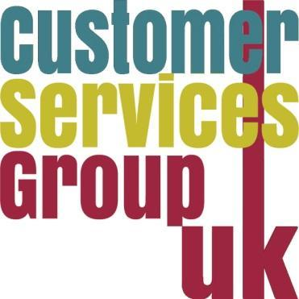
Stop,Start, Continue:

reimagining and creating sustainable library services for the future

#CSGUK24

CSGUK Annual Conference – 22 November 2024
Queen’s University Belfast (Riddel Hall)

Programme

09:00 – 9:30 | Registration and Refreshments
09:30 – 09:40 | Introductions and Housekeeping - Nuala Mclaren, Chair of CSGUK
09:40 - 09:50 | Icebreaker
09:50: 10:30 | Keynote: Jim Dickinson Associate Editor (SU’S) WonkHE
10:30-10:50 | Refreshments and networking
10:50-11:30 | Getting creative: How to engage with students on a shoestring budget. Elena Kosmala, University of Roehampton  Igniting innovative new services - The University of Bath’s library Spark Student Competition. Chris Roberts, University of Bath  The impact of SCONUL Access on distance learning success. Helen Clough, Open University
11:30 – 12:00 | Student panel
12:00 - 12:30 | Bringing retail customer service experience to the virtual engagement within the Library and Student Centre model at the University of Westminster. Charlene John and Iulia Cinpoes, University of Westminster
12:30 – 13:30 | Lunch and networking
13:30-14:30 | For staff, by staff: A learning and development group. Aoife Murphy and Nuala Murray, Dublin City university  Development and progression in Customer Services. Maria Carnegie, Durham University  Workshop - Maria Carnegie, Durham University and Rachel Heastie, CSGUK (Royal Holloway University of London)
14:30 - 14:45 | Refreshments and networking
14:45-15:45 | Building an AI Chatbot to support information provision to students. Brenda Wlch and Karen Bonthron, University of Edinburgh  Enhancing customer experience with AI: Queen’s University Belfast’s library chatbot. Robert Whan and Richard Stitt Queen’s University Belfast
15:45 | Closing remarks - Nuala MClaren Chair of CSGUK

