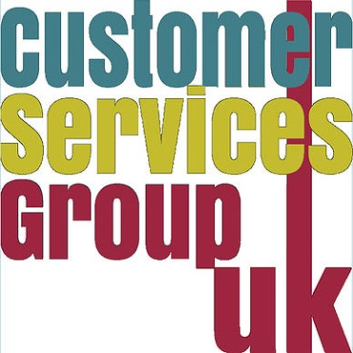

**Speedback**

**City University London**

**Library Services**

***About the organization***

**Name:** City University London

**Department:** Library Services

**Size:** 13,053 FTE students

**Industry Sector:** Higher Education

“Speedback” is an initiative of the Students Union at City University London to give students an opportunity to meet University staff from a range of service departments and give feedback on and ask questions about their services.

This was first run in the 2011/12 session – the SU Executive team were keen to give students a less formal environment to give feedback and raise questions than Staff Student Liaison Committees. Services represented have included Library Services, IT Services, Property & Facilities, Catering and the Exams Office.

The format is essentially a cross between speed dating and focus group. Each of the staff representatives had about 15 minutes to spend with one table of students (about 6-8 students per table). Students are encouraged to sign up in advance to attend but the representation across the different schools has tended to be slightly imbalanced.

One of the main strengths of the format is having different service areas together. There was a high degree of overlap and common interest for Library Services with IT colleagues and Property & Facilities in the feedback received, e.g. student frustration over printing (IT pressed ahead with implementing wireless printing after this event) and complaints about state of furniture in library.

The momentum to act in response to these messages was certainly increased by both parties hearing the same concerns in the same forum. Unfortunately, the SU Executive team has struggled to arrange the event on a regular basis. However, it has certainly given Library Services at City a template that we’re now trying to develop with focus groups being used to review different areas of our services and activity.